

汕头职业技术学院
高等职业教育质量年度报告
（2017）



广东·汕头
二〇一六年十二月

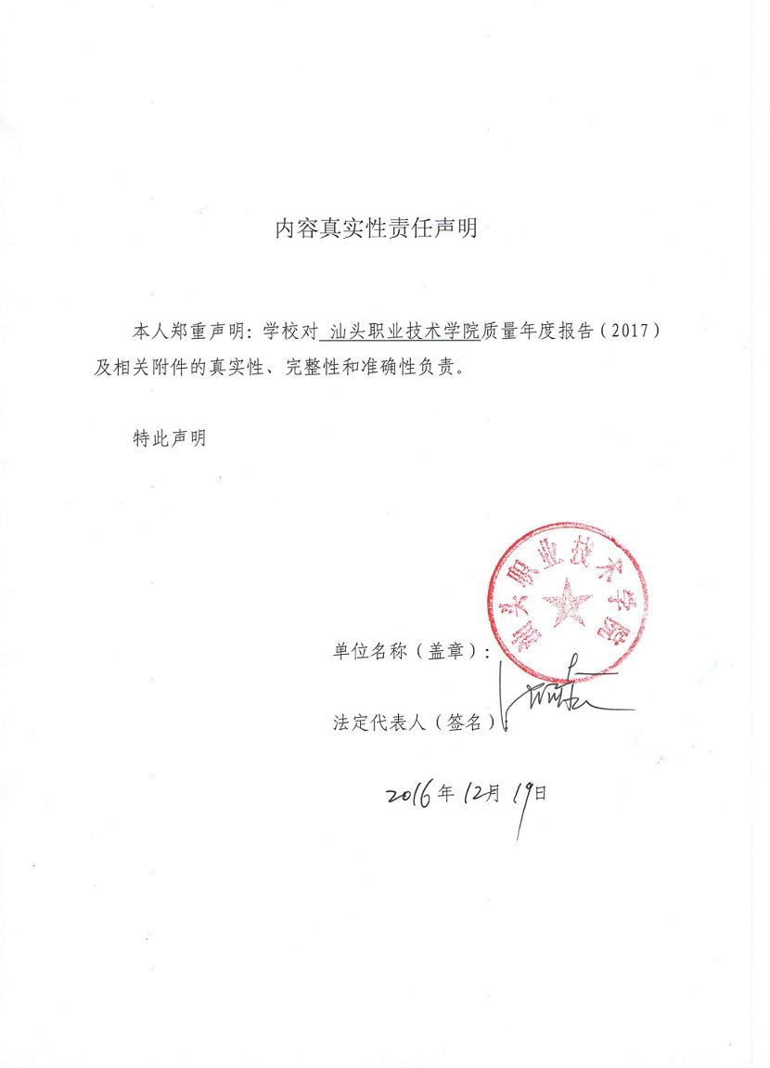
目 录

一、学院基本情况1
（一）指导思想，清晰明确1
（二）发展定位，紧切实际1
（三）办学基础，坚实深厚1
（四）发展规模，趋于稳定2
（五）整合资源，改善办学3
（六）依法治校，管理规范3
二、教学改革5
（一）立足市场，加强专业课程建设5
（二）加强调研，优化人才培养方案6
（三）多措并举，加强师资队伍建设8
（四）产教融合，助力学院转型升级9
（五）注重基础，加快教学资源建设13
三、学生发展14
（一）以人为本，注重学生在校体验14
1.招生稳定，学生质量有保障14
2.创设平台，学生活动丰富多彩15
3.倡导奉献，志愿者服务有声有色16
4.重视预防，心理健康教育到位18
5．依托竞赛，全力提升技能水平19
6．服务就业，实施双证书制度22
7．创设条件，做好奖贷勤助工作23
（二）措施到位，学生就业质量有保障24
（三）加大力度，扶持学生职业发展30
（四）提供服务，鼓励学生自主创业33
四、国际合作33
五、服务贡献36
（一）重视科技，提升服务地方能力36
（二）发挥优势，积极开拓培训服务39
（三）互利共赢，服务地方微小企业40
（四）承办活动，主动服务地方发展40
六、政策保障41
（一）服务办学，地方政策保障有力41
（二）制度保障，确保教学经费优先42
（三）积极部署，落实教学诊断与改进工作42
七、面临挑战43
（一）认真总结，正确应对面临挑战43
（二）狠抓落实，全面推进综合改革44

